LOCI AND CONSTRUCTION

OCR – Tuesday 03 November 2020- Morning - Paper 1 (Calculator) Foundation Tier
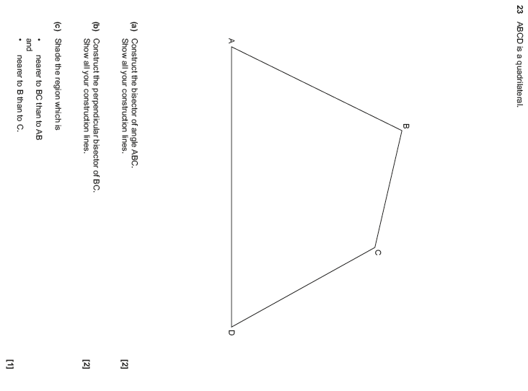

OCR Thursday 07 November 2019- Morning (Non-Calculator) Foundation Tier

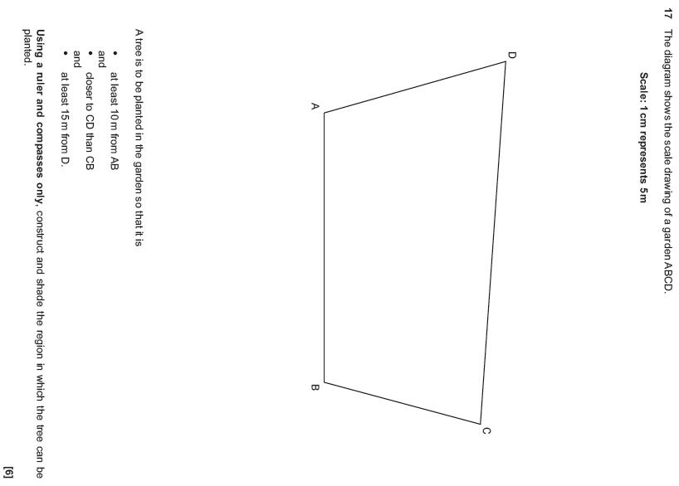

OCR Tuesday 11 June 2019 – Morning (Calculator) Foundation Tier
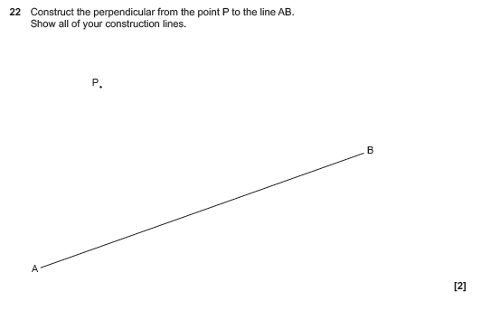

OCR Tuesday 6 November 2018 – Morning (Calculator) Foundation Tier
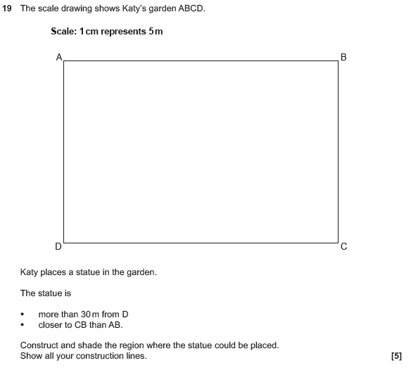

OCR Monday 12 November 2018 – Morning (Calculator) Foundation Tier
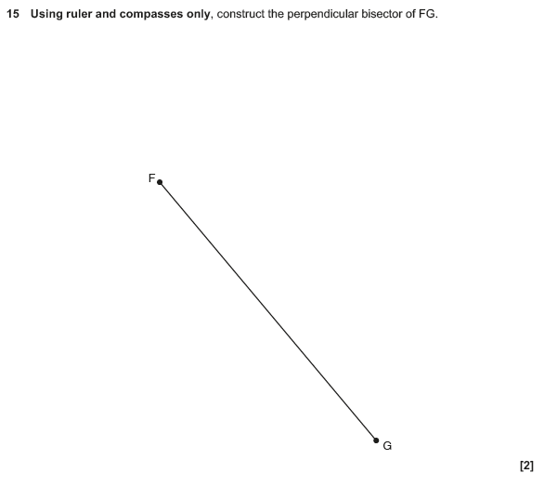

OCR Monday 24 May 2018 – Morning (Calculator) Foundation Tier

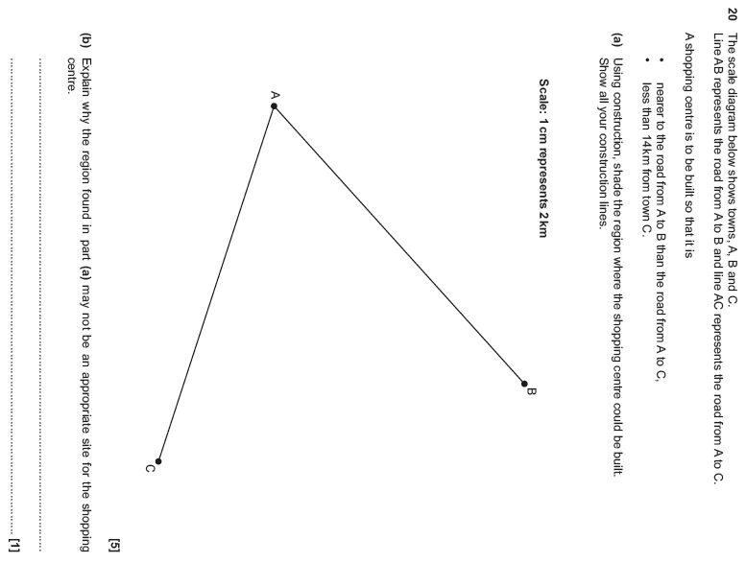

OCR Thursday 2 November 2017– Morning (Calculator) Foundation Tier

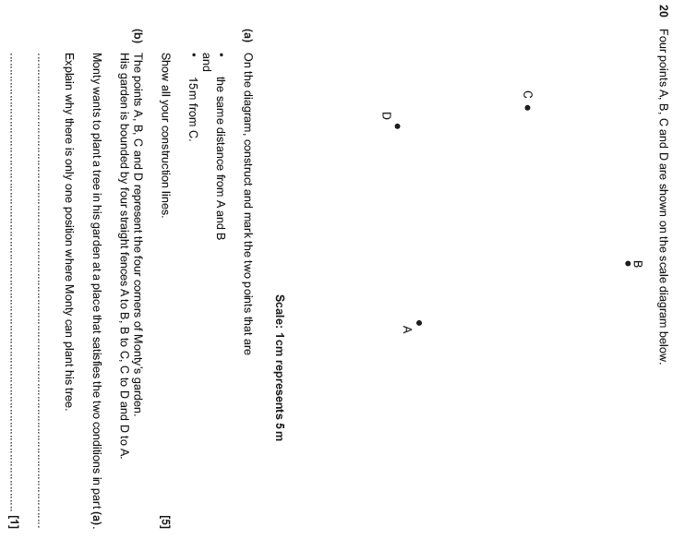

OCR Wednesday 8 November 2017– Morning (Calculator) Foundation Tier

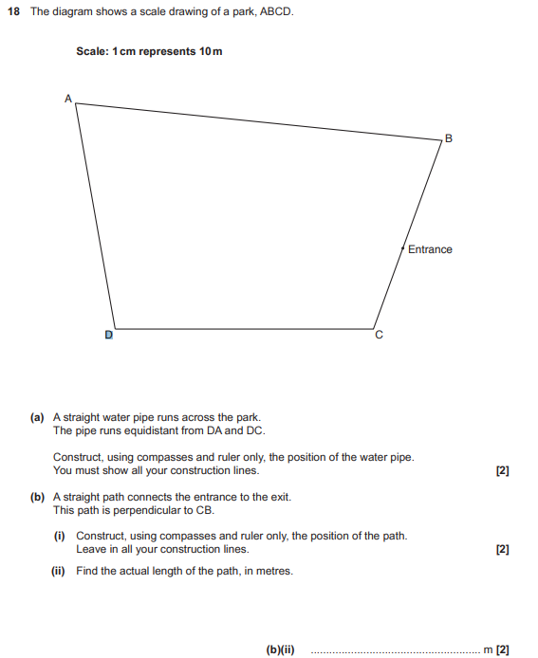

OCR Thursday 25 May 2017 – Morning (Calculator) Foundation Tier

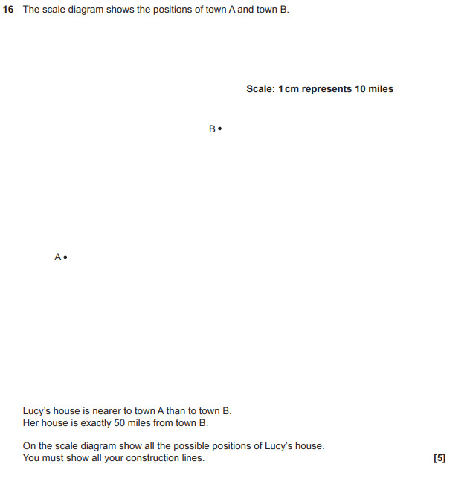

OCR Tuesday 13 June 2017 – Morning (Calculator) Foundation Tier

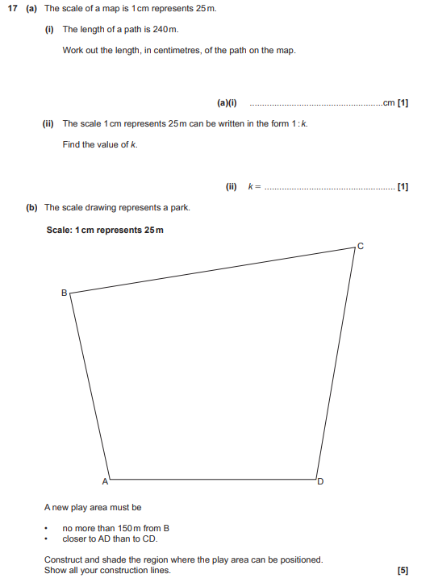

AQA Thursday 6 June 2019 – Morning (Calculator) Foundation Tier

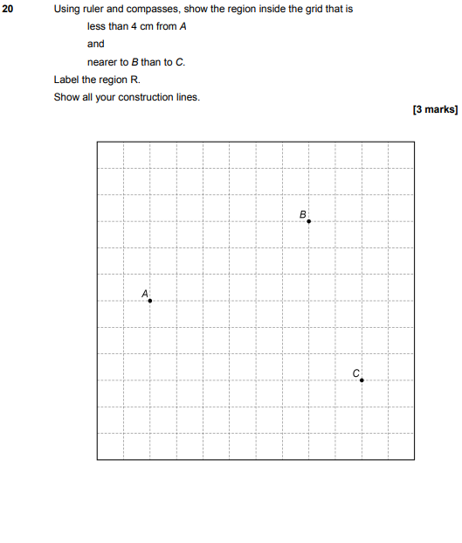

AQA Thursday 2 November 2017 – Morning (Non-Calculator) Foundation Tier

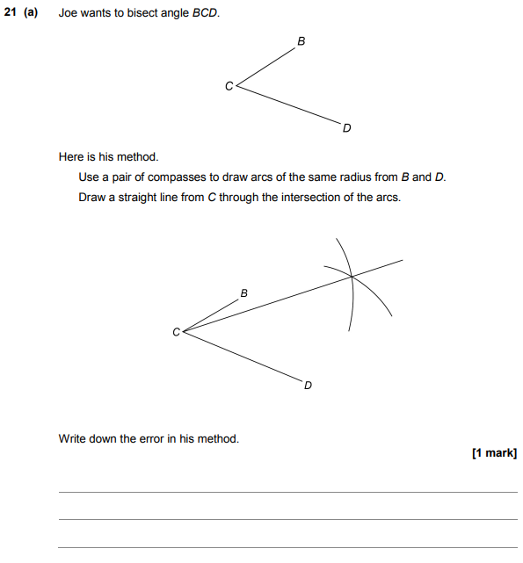
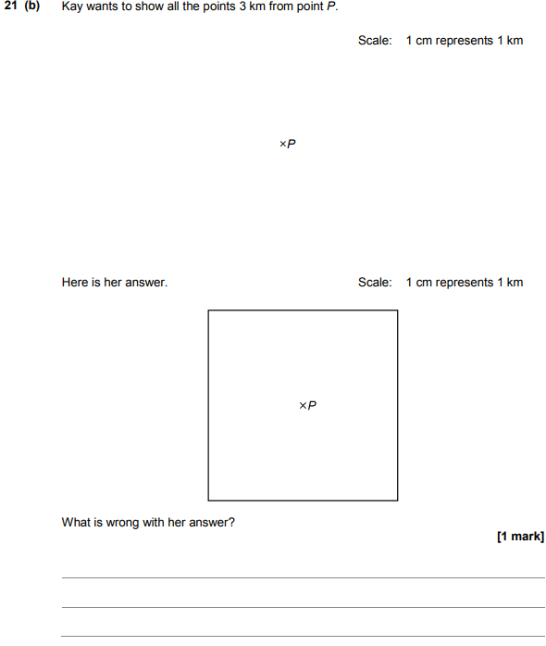
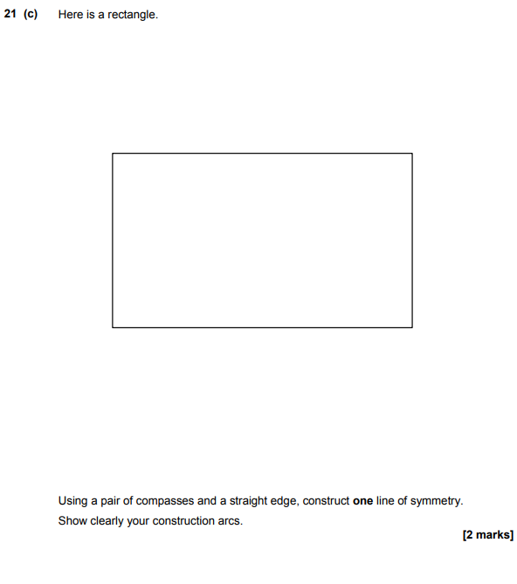

AQA Sample Paper 3– Morning (Calculator) Foundation Tier

